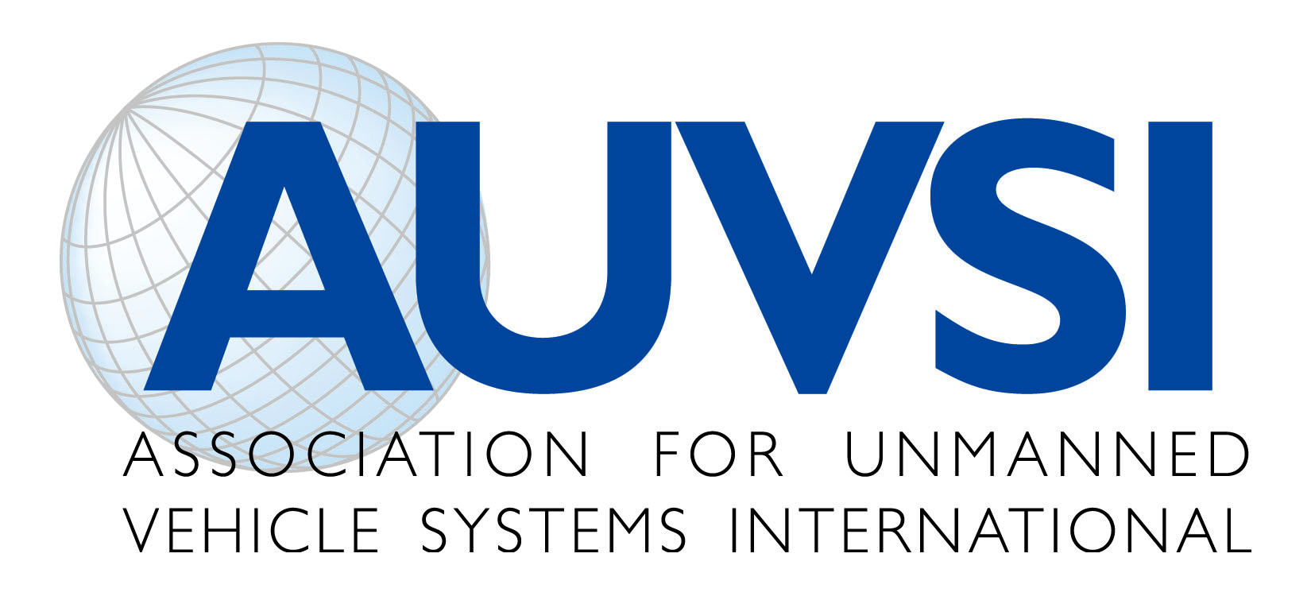

Unmanned Aircraft Systems Privacy Statement

Unmanned Aircraft Systems (UAS) increase human potential by doing dangerous or difficult tasks safely and efficiently. Whether it is improving agriculture practices and output, helping first responders, advancing scientific research, or making business more efficient, UAS are capable of saving time, saving money and most importantly, saving lives.

The Association for Unmanned Vehicle Systems International (AUVSI) supports the development and advancement of UAS technology in a safe and responsible manner, while respecting existing privacy laws and ensuring transparency and accountability. To help safeguard Americans’ right to privacy, AUVSI supports:

- The registration of unmanned aircraft and pilots with the Federal Aviation Administration (FAA).
- The enforcement of established law and policy, governing the collection, use, storage, sharing and deletion of data, regardless of how it is collected.
  - These policies should be available for public review.
  - The policies should outline strict accountability for unauthorized use.
- The International Association of Chiefs of Police recommended guidelines for UAS operations and their recommendations on data collection, which have been adopted by the Airborne Law Enforcement Association and others.
- The 4th Amendment’s requirement that the government obtain a search warrant when the use of a UAS will intrude upon someone’s reasonable expectation of privacy.
- The prosecution of individuals who misuse any technology to violate privacy laws - AUVSI does not condone the use of UAS for illegal surveillance. UAS manufacturers should not be held responsible for improper or illegal use of unmanned aircraft systems.

AUVSI recognizes this new industry is poised to create over 70,000 new jobs within the first three years of UAS being integrated into the National Airspace System in the United States; however, restrictive legislation will inhibit this new industry. AUVSI does not support restrictive legislation at the state or federal level that will prohibit, delay, or prevent the use of UAS by our public safety agencies and other end users. Many of these bills would fundamentally change current search warrant requirements, which the courts have ably shaped over the past 225 years.

The issue should be focused on the extent to which the government can collect, use and store personal data – which is why transparency and accountability are key. Instead of focusing on how the government collects information, AUVSI supports an open debate on the government’s right to collect, use, store, share, and delete personal data. AUVSI believes information gathered by a UAS should be treated no differently than information gathered by a manned aircraft, or other electronic means.

In 2012, AUVSI recently released the industry’s first Code of Conduct which is built around safety, professionalism and respect.

